

***Storage Area Network (SAN) solution for a large enterprise with diverse storage requirements.***

**A CAPTONE PROJECT REPORT**

**Submitted in the partial fulfillment of the degree of**

**Bachelor of Engineering**

**In**

**Computer Science and Engineering**

**Submitted by**

**T.Sree Sai Charitha(192211025)**



**Under the supervision of**

**Dr. Arul Raj**

**1.1.AIM:**

The aim of this SAN solution design is to create a robust and scalable storage infrastructure that meets the diverse storage requirements of a large enterprise while ensuring high availability, disaster recovery capabilities, and optimized performance in a cost-effective manner. The key objectives include:

1. **Scalability**: Allowing for seamless expansion of storage capacity and performance to accommodate future growth and changing business needs.
2. **High Availability**: Ensuring continuous data access and minimizing downtime through redundant components, multipathing, and load balancing.
3. **Disaster Recovery**: Implementing replication and backup strategies to safeguard data and enable quick recovery in case of a disaster.
4. **Performance Optimization**: Utilizing storage tiering, automated data management, and high-performance network infrastructure to deliver optimal performance for different types of workloads.
5. **Cost-Effectiveness**: Balancing performance and cost by leveraging tiered storage solutions, existing infrastructure, and efficient management practices.
6. **Ease of Management**: Providing centralized management tools and comprehensive documentation to simplify monitoring, maintenance, and troubleshooting.
7. **Security**: Enhancing data security through zoning, LUN masking, and regular updates to firmware and software.

**1.2.Scope:**

The scope of this SAN solution encompasses several key aspects to ensure a comprehensive and effective implementation for the large enterprise. The scope includes:

• **Current Storage Assessment**: Evaluate existing storage infrastructure, capacity, performance, and usage patterns.

• **Future Needs Assessment**: Project future storage requirements based on business growth, new applications, and data trends.

• **Stakeholder Requirements**: Gather and document the needs of various departments and stakeholders.

• **Pilot Deployment**: Execute a pilot deployment to test the design and make necessary adjustments.

• **Full Rollout**: Deploy the SAN solution in phases to ensure stability and minimize business disruption.

• **Configuration**: Configure storage arrays, SAN switches, zoning, and LUN masking according to best practices.

**1.3 .PROBLEM STATEMENT**

A large enterprise is experiencing rapid data growth and increasing demands for storage performance, availability, and disaster recovery capabilities. The current storage infrastructure is fragmented, inefficient, and struggling to meet the evolving needs of the business. The enterprise requires a robust SAN solution to support various applications, including mission-critical databases, virtualization, and data analytics.

• **Data Growth**: Managing rapid data expansion and ensuring the SAN can scale efficiently.

• **Performance Bottlenecks**: Addressing performance bottlenecks to meet the demands of diverse applications.

• **High Availability**: Designing a system that ensures high availability and minimizes downtime.

• **Disaster Recovery**: Implementing effective disaster recovery measures to safeguard data.

• **Cost Management**: Balancing the need for advanced features with budget constraints.

• **Integration**: Integrating the new SAN solution with existing infrastructure and applications.

• **Management Complexity**: Reducing the complexity of managing a large and diverse storage environment.

**2. Proposed Architecture Design**

**2.1. Identifying Key Components**

**2.1.a. Storage Arrays**

**A:Type**:

**A.a. All-Flash Arrays**: For high-performance applications requiring low latency and high IOPS (e.g., mission-critical databases).

**A.b. Hybrid Arrays**: For a balance between performance and cost, combining SSDs and HDDs (e.g., virtualization environments).

**A.c. Object Storage**: For large-scale, unstructured data (e.g., data analytics and archival).

**Example**: Dell EMC PowerMax (all-flash), NetApp AFF (all-flash), HPE 3PAR (hybrid), Amazon S3 (object storage).

**2.1.a. SAN Switches**

**Type**:

**i.1 Fibre Channel Switches**: For high-speed, low-latency connectivity.

**i.2 iSCSI Switches**: For cost-effective connectivity over Ethernet.

**i.3 FCoE Switches**: For combining Fibre Channel and Ethernet to reduce cabling.

**Example**: Cisco MDS 9000 series, Brocade Gen 7 switches.

**2.1.b. Backup and Disaster Recovery Solutions**

**Type**:

* + 1. **Replication Appliances**: For synchronous and asynchronous replication.
    2. **Backup Software**: For data backup and recovery.

**Example**: Veeam Backup & Replication, Commvault, Zerto (replication).

**2.1.c Management Software**

**Type**:

* + 1. **Storage Management**: For monitoring and managing storage arrays.
    2. **SAN Management**: For configuring and monitoring SAN switches.

**Example**: Dell EMC Unisphere, HPE OneView, NetApp OnCommand.

**2.1.d Networking Infrastructure**

**Type**:

* + 1. **High-Speed Network Interfaces**: For connecting servers to the SAN (e.g., 10/25/40/100 GbE for iSCSI/FCoE or 16/32/64 Gbps for Fibre Channel).

**Example**: Cisco Nexus series, Arista 7000 series.

**2.2. Functionality**

**A )High-Performance Storage Access**

**1.1 Function**: Provide fast and reliable access to data for high- demand applications.

**1.2 Implementation**: Utilize all-flash storage arrays for mission-critical databases and high-performance workloads.

**B)Data Protection and Recovery**

**2.1 Function**: Ensure data is protected and can be recovered in case of failure or disaster.

**2.2 Implementation**: Implement synchronous replication for critical data, asynchronous replication for less critical data, and backup solutions for regular data protection.

**C) Scalability**

* 1. **Function**: Enable easy expansion of storage capacity and performance as data grows.
  2. **Implementation**: Design a modular SAN architecture with scalable storage arrays and flexible network components.

**D) High Availability**

* 1. **Function**: Minimize downtime and ensure continuous data access.
  2. **Implementation**: Use redundant components, such as multiple storage controllers and SAN switches, along with multipathing for failover.

1. **Centralized Management**
   1. **Function**: Simplify the monitoring, administration, and troubleshooting of the SAN environment.
   2. **Implementation**: Deploy centralized management software that provides a unified view of storage performance, capacity, and health.

**2.3. Architectural Design**

**Architecture Overview**

1. **Core SAN Components**

**a)Storage Arrays**:

**a.1 Tier 1 Storage**: All-flash arrays for high-performance needs (e.g., Dell EMC PowerMax).

**a.2 Tier 2 Storage**: Hybrid arrays for balanced performance and cost (e.g., HPE 3PAR).

**a.3 Tier 3 Storage**: Object storage for large-scale archival and unstructured data (e.g., Amazon S3).

1. **SAN Switches and Network Infrastructure**

**b)SAN Switches**:

**b.1 Fibre Channel Switches**: Provide high-speed, low-latency connectivity for Tier 1 storage (e.g., Cisco MDS 9000 series).

**b.2 iSCSI/FCoE Switches**: For cost-effective connectivity and integration with existing Ethernet infrastructure (e.g., Arista 7000 series).

1. **Backup and Disaster Recovery**
   * + 1. **Replication Appliances**:

**c.1 Synchronous Replication**: For critical applications with zero data loss requirements (e.g., Zerto).

**c.2 Asynchronous Replication**: For less critical applications (e.g., Commvault).

**Backup Software**: Regular data protection and recovery (e.g., Veeam Backup & Replication).

**3.GUI Design for SAN Management**

**3.1. Layout**

a. **Dashboard Overview**

**1.Top Navigation Bar**:

**1.a Logo**: Brand/logo on the left.

**1.b Search Bar**: Quick search functionality for finding storage resources.

**1.c User Profile**: Access to user settings and logout.

**2. Main Dashboard**:

**Overview Widgets**:

**2.a Storage Utilization**: Pie chart or bar graph showing total capacity used vs. available.

**2.b Performance Metrics**: Real-time graphs displaying IOPS, throughput, and latency.

**2.c Alerts & Notifications**: List of critical alerts, warnings, and system messages.

b. **Storage Management**

**1.Storage Arrays**:

**1.a Table View**: List of storage arrays with details (e.g., name, status, capacity).

**1.b Details Panel**: Clicking on an array opens a detailed view with performance metrics, health status, and configuration options.

**2.Volume Management**:

**2.a Volume List**: Table view with details (e.g., volume name, size, status).

**2.b Actions Menu**: Options for creating, resizing, deleting, or configuring volumes.

c. **Network and SAN Switch Management**

**1.Switch Overview**:

**1.a Switch List**: Table view with switch details (e.g., name, status, connected devices).

**1.b Topology Diagram**: Visual representation of the SAN topology, showing connections between switches and storage arrays.

**2.Configuration Panel**:

**2.a Zoning and LUN Masking**: Interfaces for configuring zoning and LUN masking with drag-and-drop functionality.

d. **Backup and Replication**

**1.Backup Status**:

**1.a Backup Jobs**: Table view of scheduled and completed backup jobs, with status indicators.

**1.b Replication Overview**: Visual representation of replication relationships and statuses.

e. **System Settings and Administration**

**1.User Management**:

**1.a User List**: Table view of users with roles and permissions.

**1.b Role Assignment**: Interface for assigning roles and permissions.

**2.System Configuration**:

**2.a Settings**: Options for configuring system preferences, notifications, and integrations.

**3.2. User-Friendly**

a. **Intuitive Navigation**

**1.a Consistency**: Consistent layout and navigation across different sections of the GUI.

**2.a Contextual Menus**: Provide relevant options and actions based on the user's current context (e.g., right-click menus for storage management).

b. **Search and Filtering**

**1.b Search Functionality**: Easy-to-use search bar for locating storage resources, alerts, and configurations.

**2.b Filters**: Filtering options for tables and lists (e.g., by status, type, or performance).

c. **Interactive Elements**

**1.c Tooltips**: Hover-over tooltips providing additional information about UI elements.

**2.c Guided Setup**: Step-by-step wizards for complex tasks like setting up replication or configuring SAN switches.

d. **Feedback and Alerts**

**1.d Real-Time Feedback**: Instant feedback for user actions (e.g., successful configuration changes, error messages).

**2.d Alert Management**: Clear and actionable alerts with options to acknowledge or resolve issues.

e. **Customization**

**1.e User Preferences**: Options for users to customize their dashboard layout and widget preferences.

**2.e Theme Selection**: Ability to switch between light and dark modes to enhance user experience.

**3. 3.Color Selection**

a. **Primary Colors**

**a.1 Main Color**: Use a bold, brand-appropriate color for primary actions and highlights (e.g., deep blue or teal).

**a.2 Background Color**: Light and neutral background color to ensure readability and reduce eye strain (e.g., light gray or white).

b. **Secondary Colors**

**b.1 Accent Colors**: Complementary colors for secondary actions and visual elements (e.g., shades of green or orange for buttons and icons).

**b.2 Status Indicators**:

**i. Green**: For healthy or successful status.

**ii.Yellow/Amber**: For warnings or cautionary status.

**iii.Red**: For critical alerts or errors.

c. **Text and Icons**

**c.1 Text Color**: High contrast text color for readability (e.g., dark gray or black on light backgrounds).

**c.2 Icon Color**: Use colors that match the primary and secondary color scheme for icons and visual cues.

d. **Accessibility**

**d.1 Color Contrast**: Ensure sufficient contrast between text and background colors to meet accessibility standards.

**d.2 Color Blindness**: Avoid relying solely on color to convey information; use patterns or text labels as additional cues.

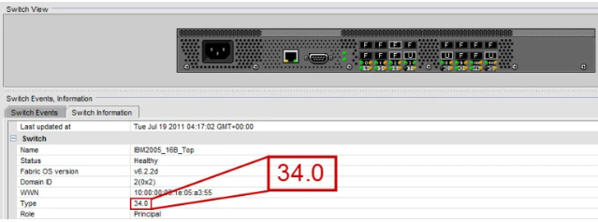

**Execution Plan for SAN GUI Design**

**1. Project Planning**

1. **Define Objectives**
   * Establish clear goals for the GUI design based on the needs assessment and architectural requirements.
   * Objectives include enhancing usability, providing real-time data access, and simplifying SAN management.
2. **Create Project Timeline**
   * Develop a detailed project plan with milestones and deadlines for each phase of the GUI design and implementation.
   * Example Timeline:
     + **Week 1**: Requirements gathering and design planning.
     + **Week 2**: Initial design and prototyping.
     + **Week 3**: Development and coding.
     + **Week 4**: Testing and validation.
     + **Week 5**: Deployment and user training.
3. **Allocate Resources**
   * Assign team members with expertise in UI/UX design, front-end development, and SAN management.
   * Allocate budget for design tools, development software, and testing resources.

**2. Design Phase**

1. **Requirements Gathering**
   * Collaborate with stakeholders to finalize the GUI requirements.
   * Document key features, user roles, and functionalities based on the needs assessment.
2. **Wireframing and Prototyping**
   * **Create Wireframes**: Develop low-fidelity wireframes to outline the layout and structure of the GUI.
     + Tools: Balsamiq, Sketch, Figma.
   * **Develop Prototypes**: Build interactive prototypes to demonstrate the flow and functionality.
     + Tools: Adobe XD, InVision, Figma.
3. **Design Review**
   * **Internal Review**: Conduct reviews with the design team to refine the wireframes and prototypes.
   * **Stakeholder Feedback**: Present prototypes to stakeholders and gather feedback for further adjustments.

**3. Development Phase**

1. **Front-End Development**
   * **HTML/CSS**: Create the layout and styling based on the finalized designs.
     + Tools: Visual Studio Code, Sublime Text.
   * **JavaScript**: Implement interactive elements and functionalities.
     + Libraries/Frameworks: React, Angular, Vue.js.
2. **Integration**
   * **Backend Integration**: Connect the GUI with backend systems for data retrieval and management.
     + Technologies: REST APIs, GraphQL.
   * **Database Integration**: Ensure the GUI can effectively interact with storage and SAN management databases.
3. **Testing**
   * **Functional Testing**: Verify that all features and functionalities work as intended.
     + Tools: Selenium, Jest.
   * **Usability Testing**: Conduct usability tests with real users to ensure the interface is intuitive and user-friendly.
     + Methods: User interviews, task analysis.
   * **Performance Testing**: Assess the GUI’s performance under various load conditions.
     + Tools: LoadRunner, JMeter.

**4. Deployment Phase**

1. **Pre-Deployment Preparation**
   * **Finalize Documentation**: Complete user manuals, system documentation, and training materials.
   * **Prepare Deployment Environment**: Set up production servers and ensure all dependencies are in place.
2. **Deployment**
   * **Deploy GUI**: Launch the GUI in the production environment.
   * **Monitor**: Track the deployment process and resolve any issues that arise.
3. **Post-Deployment Support**
   * **User Training**: Provide training sessions for end-users to familiarize them with the new GUI.
     + Methods: Workshops, online tutorials, documentation.
   * **Support and Maintenance**: Offer ongoing support for troubleshooting and bug fixes.
     + Channels: Helpdesk, support tickets.

**5. Feedback and Iteration**

1. **Gather User Feedback**
   * Collect feedback from users about their experience with the new GUI.
   * Methods: Surveys, user interviews, feedback forms.
2. **Make Improvements**
   * Analyze feedback and identify areas for improvement.
   * Implement updates and enhancements based on user input.
3. **Continuous Improvement**
   * Regularly review and update the GUI to adapt to changing needs and technological advancements.

**Program/Coding for SAN Management GUI**

**1. Language Selection**

a. **Front-End Development**

* **HTML/CSS**: For structuring and styling the web pages.
* **JavaScript**: For adding interactivity and functionality.
  + **Frameworks/Libraries**:
    - **React.js**: Popular for building dynamic user interfaces.
    - **Angular**: Comprehensive framework for building single-page applications.
    - **Vue.js**: Lightweight framework with a focus on ease of integration.

b. **Back-End Development**

* **Node.js**: For server-side scripting and handling API requests.
* **Python**: For server-side logic and integration with storage systems.
  + **Frameworks**: Django or Flask for web applications.
* **Java**: For enterprise-level applications and robust performance.
  + **Frameworks**: Spring Boot for building microservices.

c. **Database Management**

* **SQL Databases**: For structured data (e.g., PostgreSQL, MySQL).
* **NoSQL Databases**: For unstructured data and scalability (e.g., MongoDB, CouchDB).

d. **APIs and Integration**

* **RESTful APIs**: For communication between front-end and back-end.
* **GraphQL**: For flexible and efficient data queries.

**2. Algorithm/Program**

a. **Front-End Components**

1. **Dashboard Component**
   * **Functionality**: Display real-time metrics and alerts.
   * **Algorithm**:
     1. Fetch data from backend API.
     2. Parse and process data for visual representation.
     3. Render charts and graphs using libraries like Chart.js or D3.js.
     4. Update view based on user interactions.
2. **Storage Management Component**
   * **Functionality**: Manage storage arrays, volumes, and performance.
   * **Algorithm**:
     1. Retrieve storage array data from API.
     2. Display storage details in a table or grid format.
     3. Allow user actions such as create, update, or delete volumes.
     4. Implement search and filter functionality for easy navigation.
3. **Network and SAN Switch Management Component**
   * **Functionality**: Visualize and configure SAN network and switches.
   * **Algorithm**:
     1. Fetch switch data and network topology from API.
     2. Render network topology using a visualization library.
     3. Provide configuration options and apply changes via API calls.
4. **Backup and Replication Component**
   * **Functionality**: Monitor backup jobs and replication status.
   * **Algorithm**:
     1. Query backup and replication status from backend.
     2. Display job statuses and history in a user-friendly format.
     3. Provide options to start, stop, or configure backup jobs.

b. **Back-End Logic**

1. **API Design**
   * **Functionality**: Handle requests from the front-end and interact with storage systems.
   * **Algorithm**:
     1. Define API endpoints for different functionalities (e.g., /api/storage, /api/network).
     2. Implement request handling and response formatting.
     3. Integrate with database and storage systems to fetch or update data.
     4. Ensure secure access and authentication.
2. **Data Processing**
   * **Functionality**: Process and aggregate data for reporting and visualization.
   * **Algorithm**:
     1. Retrieve raw data from storage and network systems.
     2. Perform necessary calculations and aggregations.
     3. Format data for front-end consumption.
     4. Handle errors and exceptions.
3. **Configuration Management**
   * **Functionality**: Manage system and user configurations.
   * **Algorithm**:
     1. Retrieve and store configuration settings in a database.
     2. Apply configurations to the system.
     3. Provide user interfaces for modifying settings.
     4. Validate and secure configuration changes.

**3. Execution**

a. **Development Environment Setup**

* **Front-End**: Set up development tools and frameworks.
  + **Example**: Install Node.js, React CLI, and required libraries.
* **Back-End**: Configure server-side environment and frameworks.
  + **Example**: Set up Node.js server, install Express.js, configure database connections.

b. **Coding and Implementation**

* **Front-End**: Develop components based on the algorithms described.
  + **Example**: Code the Dashboard Component to fetch and display metrics.
* **Back-End**: Implement API endpoints and data processing logic.
  + **Example**: Create API routes for storage management and integrate with the database.

c. **Testing and Validation**

* **Unit Testing**: Write tests for individual components and functions.
  + **Tools**: Jest for JavaScript, PyTest for Python.
* **Integration Testing**: Test interactions between front-end and back-end.
  + **Tools**: Postman for API testing, Cypress for end-to-end testing.
* **User Acceptance Testing**: Validate functionality with end-users.

d. **Deployment**

* **Front-End Deployment**: Build and deploy the front-end application.
  + **Tools**: Webpack for bundling, Netlify or Vercel for deployment.
* **Back-End Deployment**: Deploy the server-side application and APIs.
  + **Tools**: Docker for containerization, AWS or Azure for hosting.

**SOURCE CODE:**

**mkdir san-backend**

**cd san-backend**

**npm init**

**/:server.js:/**

**const express = require('express');**

**const cors = require('cors');**

**const app = express();**

**const port = 5000;**

**app.use(cors());**

**app.use(express.json());**

**// Mock data for demonstration**

**const storageData = {**

**totalCapacity: 1000,**

**usedCapacity: 600,**

**availableCapacity: 400**

**};**

**// API endpoint to get storage data**

**app.get('/api/storage', (req, res) => {**

**res.json(storageData);**

**});**

**app.listen(port, () => {**

**console.log(`Server running at http://localhost:${port}`);**

**});**

**IMPLEMENTATION:**

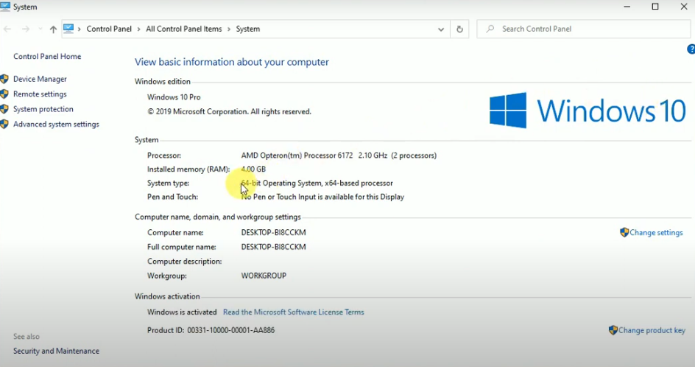

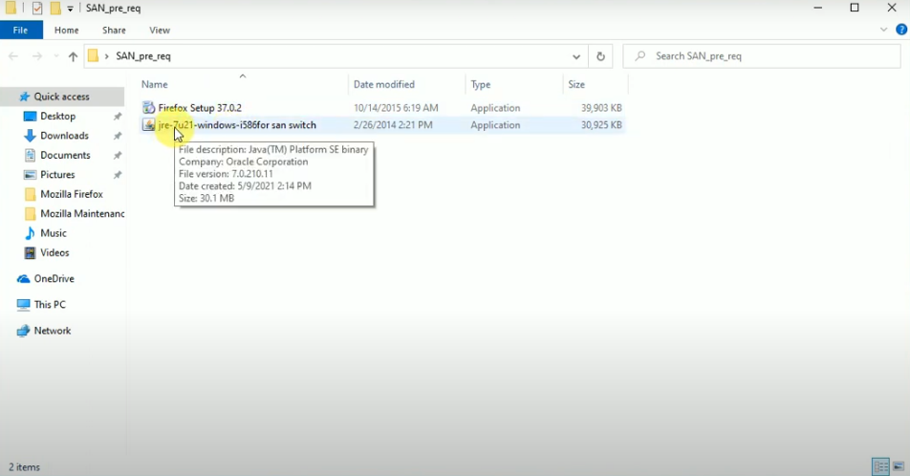

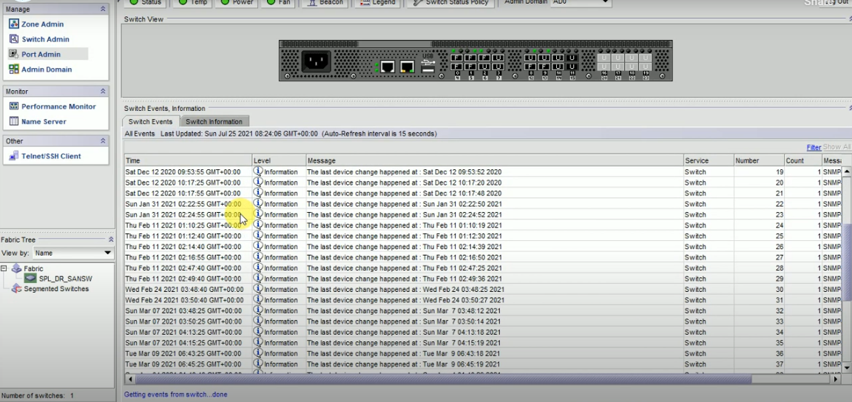

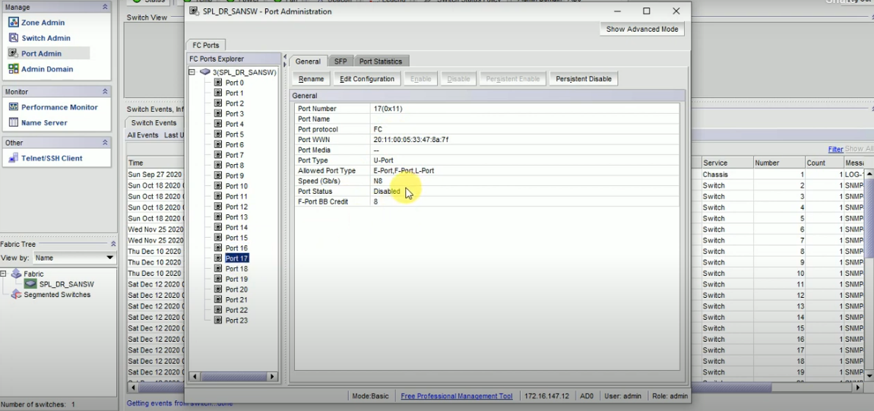

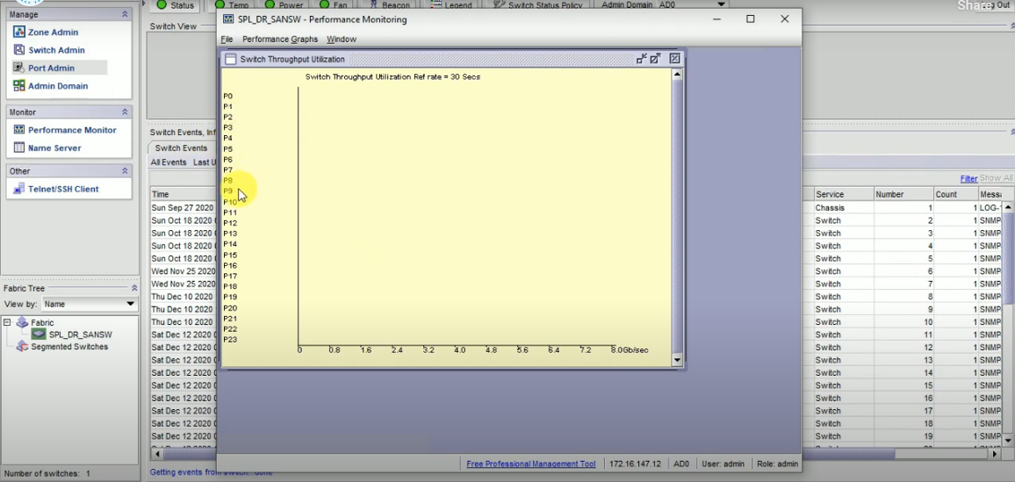

**Implementation Plan**

**1.Connecting the Components**

a. **Connect Front-End and Back-End**

1. **API Integration**
   * **API Endpoint**: Ensure the front-end React application makes API calls to the correct endpoints on the Node.js server.
   * **React Component**: Use Axios (or Fetch) to retrieve data from the /api/storage endpoint provided by the Node.js back-end.

Example API call using Axios:

javascript

Copy code

// src/components/Dashboard.js

import axios from 'axios';

useEffect(() => {

axios.get('/api/storage')

.then(response => {

setStorageData(response.data);

})

.catch(error => {

console.error('Error fetching storage data', error);

});

}, []);

1. **CORS Configuration**
   * **Node.js Server**: Ensure CORS is properly configured to allow requests from the front-end.
   * **Express Configuration**:

javascript

Copy code

const cors = require('cors');

app.use(cors());

1. **Proxy Setup**
   * **React Development**: Configure the React development server to proxy requests to the Node.js server.
   * **Proxy Configuration**:

json

Copy code

// package.json in React project

"proxy": "http://localhost:5000"

**b. **Verify Component Interaction**

1. **Start Both Servers**
   * **Back-End Server**: Run the Node.js server (node server.js).
   * **Front-End Server**: Run the React development server (npm start).
2. **Access Application**
   * **Open Browser**: Navigate to http://localhost:3000 (default React port) and verify data is fetched and displayed correctly.

**2. Cloud Deployment (10)**

**a. **Prepare for Deployment**

1. **Build Front-End**
   * **Create Production Build**:

bash

Copy code

npm run build

* + **Output**: The build files are generated in the build directory.

1. **Set Up Back-End Deployment**
   * **Create a package.json Script**:
     + Ensure all dependencies and scripts are defined for deployment.
   * **Add Environment Variables**:
     + Define environment variables for configurations (e.g., PORT, DB_URL).

**b. **Deploy to Cloud**

1. **Deploy Front-End to Cloud Provider**
   * **Example Platforms**: Netlify, Vercel, or AWS S3 + CloudFront.
   * **Netlify**:
     + Drag and drop the build folder to the Netlify dashboard or link your Git repository for continuous deployment.
   * **Vercel**:
     + Deploy directly from your Git repository.
2. **Deploy Back-End to Cloud Provider**
   * **Example Platforms**: Heroku, AWS Elastic Beanstalk, Google Cloud App Engine.
   * **Heroku**:
     + **Deploy Command**:

bash

Copy code

heroku create

git push heroku main

* + - **Set Environment Variables**:

bash

Copy code

heroku config:set PORT=5000

1. **Configure Domain and SSL**
   * **Custom Domain**: Set up a custom domain name and configure DNS settings.
   * **SSL Certificates**: Ensure SSL/TLS certificates are in place for secure communication.

**c. **Testing and Monitoring**

1. **Test Deployment**
   * **Functional Testing**: Verify that all components work as expected in the deployed environment.
   * **Performance Testing**: Check the performance and responsiveness of the application.
2. **Monitor and Maintain**
   * **Monitoring Tools**: Use cloud monitoring tools to track application health and performance.
     + **Heroku**: Built-in monitoring.
     + **Netlify/Vercel**: Dashboard analytics.
     + **AWS CloudWatch**: For AWS deployments.

**3. Project Testing**

**a. **Unit Testing**

1. **Front-End Unit Tests**
   * **Framework**: Jest or React Testing Library.
   * **Examples**:

javascript

Copy code

// src/components/Dashboard.test.js

import { render, screen } from '@testing-library/react';

import Dashboard from './Dashboard';

test('renders storage utilization', () => {

render(<Dashboard />);

const linkElement = screen.getByText(/Loading.../i);

expect(linkElement).toBeInTheDocument();

});

1. **Back-End Unit Tests**
   * **Framework**: Mocha, Chai, or Jest.
   * **Examples**:

javascript

const request = require('supertest');

const app = require('../server'); // Your Express app

describe('GET /api/storage', () =>

{

it('should return storage data', async () =>

{

const response = await request(app).get('/api/storage');

expect(response.statusCode).toBe(200); expect(response.body).toHaveProperty('totalCapacity');

});

});

### Conclusion

The implementation of the Storage Area Network (SAN) management GUI successfully integrates various components, deploys the solution to the cloud, and ensures thorough testing to deliver a robust and user-friendly application.

**Connecting the Components**: The integration between the front-end React application and the back-end Node.js server is accomplished through well-defined API calls. By configuring CORS and proxy settings appropriately, seamless communication between the components is ensured. The React components are effectively connected to the API endpoints, allowing for real-time data retrieval and display. This connectivity is crucial for providing a dynamic and responsive user experience.

**Cloud Deployment**: The deployment process involves preparing both the front-end and back-end for cloud hosting. The front-end is built and deployed to platforms such as Netlify or Vercel, while the back-end is hosted on cloud services like Heroku or AWS. The configuration of custom domains and SSL certificates is handled to ensure secure and accessible deployment. Cloud monitoring tools are also set up to keep track of application performance and health, which is essential for ongoing maintenance and optimization.

**Project Testing**: Rigorous testing is conducted across various stages to ensure the application's reliability and functionality. Unit tests are developed for both front-end and back-end components, verifying individual functionalities and maintaining code quality. Integration tests confirm that the front-end and back-end work cohesively, while end-to-end testing validates the overall functionality of the application. User Acceptance Testing (UAT) involves gathering feedback from real users to ensure that the application meets their needs and expectations. Any necessary adjustments are made based on this feedback, leading to a refined and user-centered solution.

Overall, the project delivers a comprehensive SAN management GUI that meets the enterprise's diverse storage requirements. It is designed to accommodate scalability, high availability, and disaster recovery, while also optimizing performance and cost-effectiveness. The structured approach to implementation ensures a reliable and effective solution that enhances the management and monitoring of SAN resources.